Step by step for installing python and pycharm!

1. Install Python by going to <https://www.python.org/downloads/>
2. Download the latest version (currently 3.8.2)
3. This will download.
4. Open the downloaded pthon-3.8.2.exe file
5. If you have administrator privilege: Click install now and to the location given. Make sure to click install launcher for all users

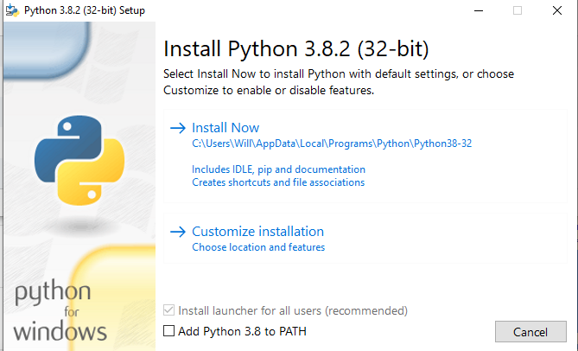

1. This will install and take a few moments
2. Once this is done, you should see this screen:

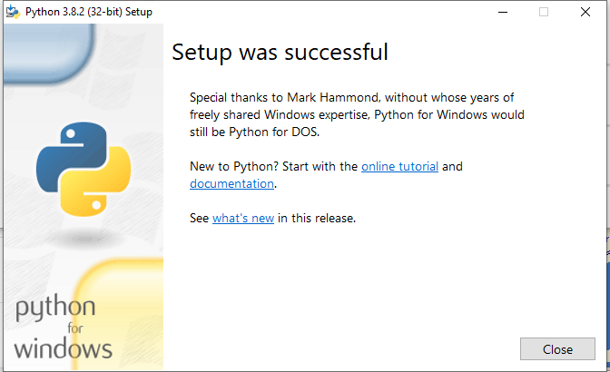

1. Now it is time to install pycharm. Go to: <https://www.jetbrains.com/pycharm/download/#section=windows> and download the community version
2. Open the pycharm-community-2020.exe file downloaded.

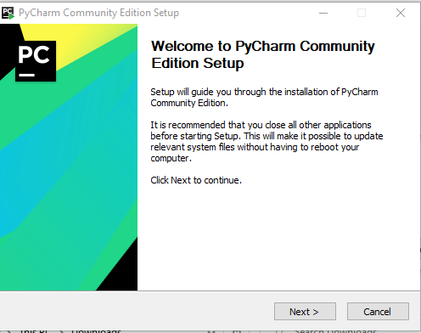

1. Click next

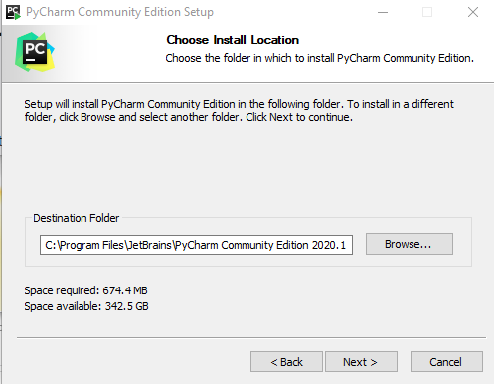

1. Allow this to be installed in the standard location and click next

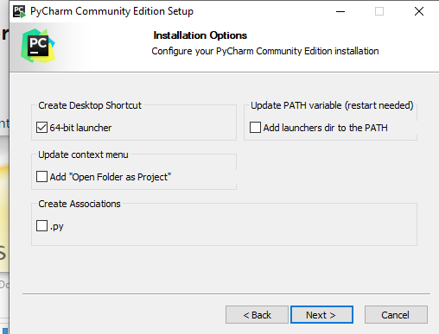

1. It is recommended you click the 64-bit launcher checkbox

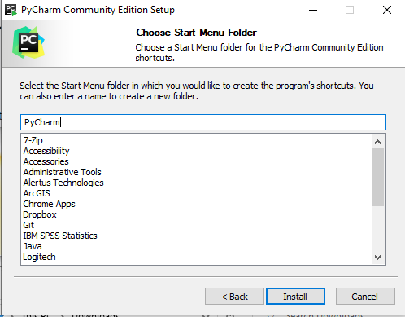

1. You may change the Start Shortcut name if you’d like. I have changed it above from “Jetbrains” to “PyCharm”
2. Then click install.
3. This will take a few moments

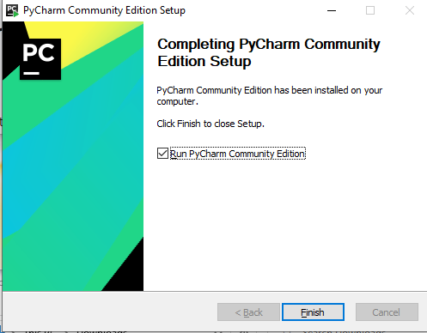

1. Click the run checkbox and then click finish

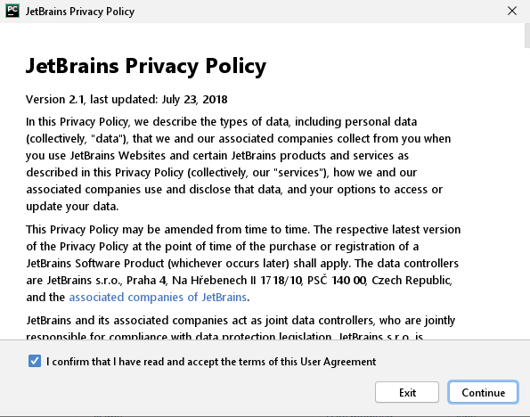

1. Click conform and continue and it is up to you whether or not to share your data
2. Choose the settings as you like and click continue.
3. Now you will get to a screen like this:

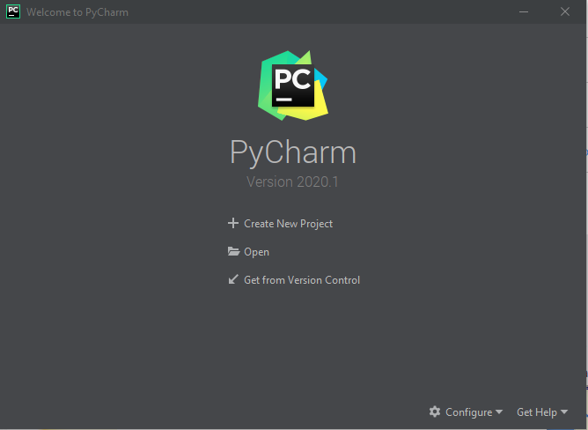

1. Click create new project

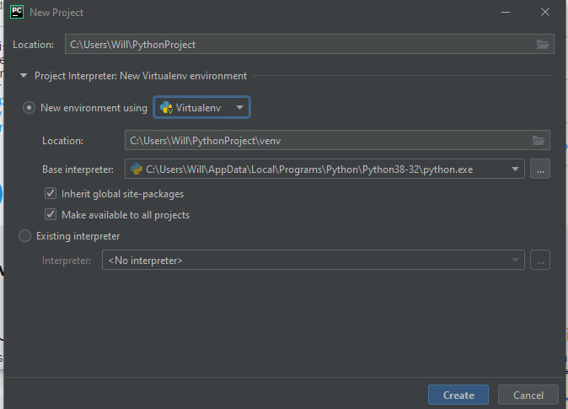

1. Name the location to the location that you want to do you PyCharm work in. Then click inherit global and make available to all projects.
2. Then click create
3. This will take a few moments to create.

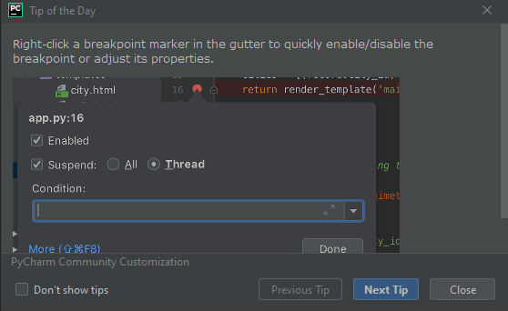

1. If a “Tip of the day” comes up, close it.
2. We have now created our environment.

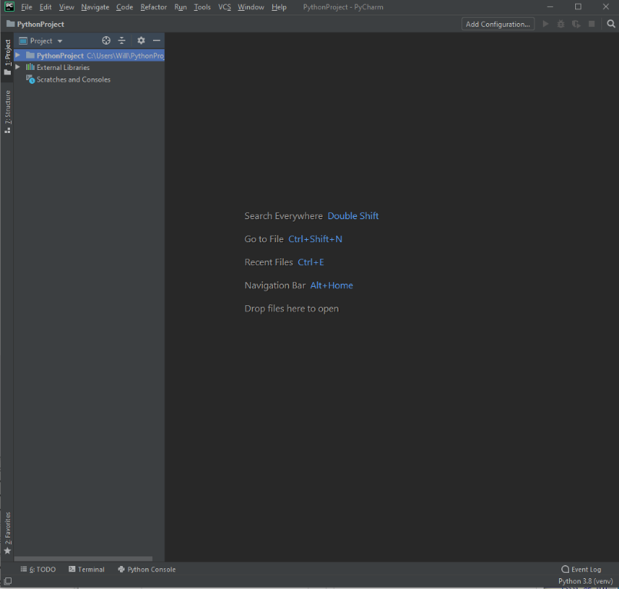

1. In Finder, open the folder you created in Step 21
2. 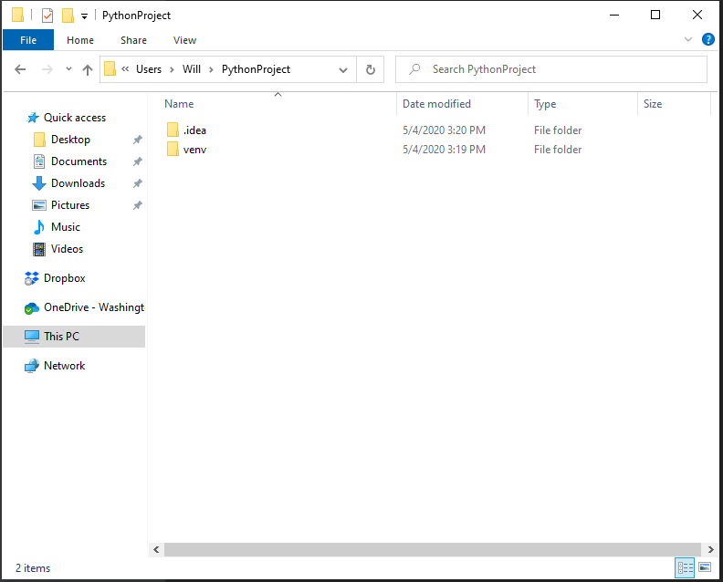
3. Create a new folder called ReadyOp

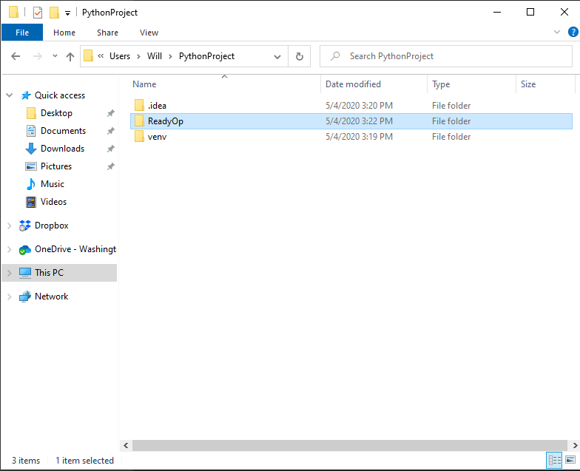

1. Open that folder and Copy the files ReadyOpEnter.py and ReadyOpSettup.py into this folder

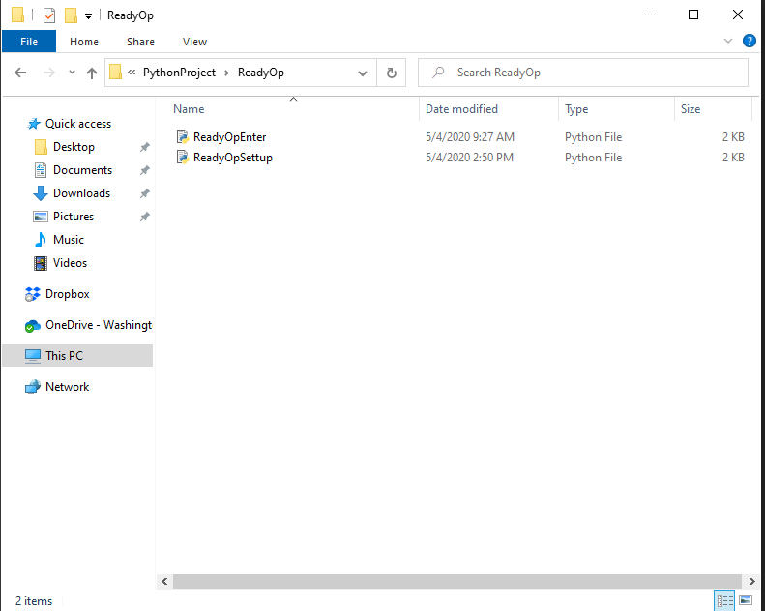

1. Now go back to PyCharm and in the left sidebar open the folders

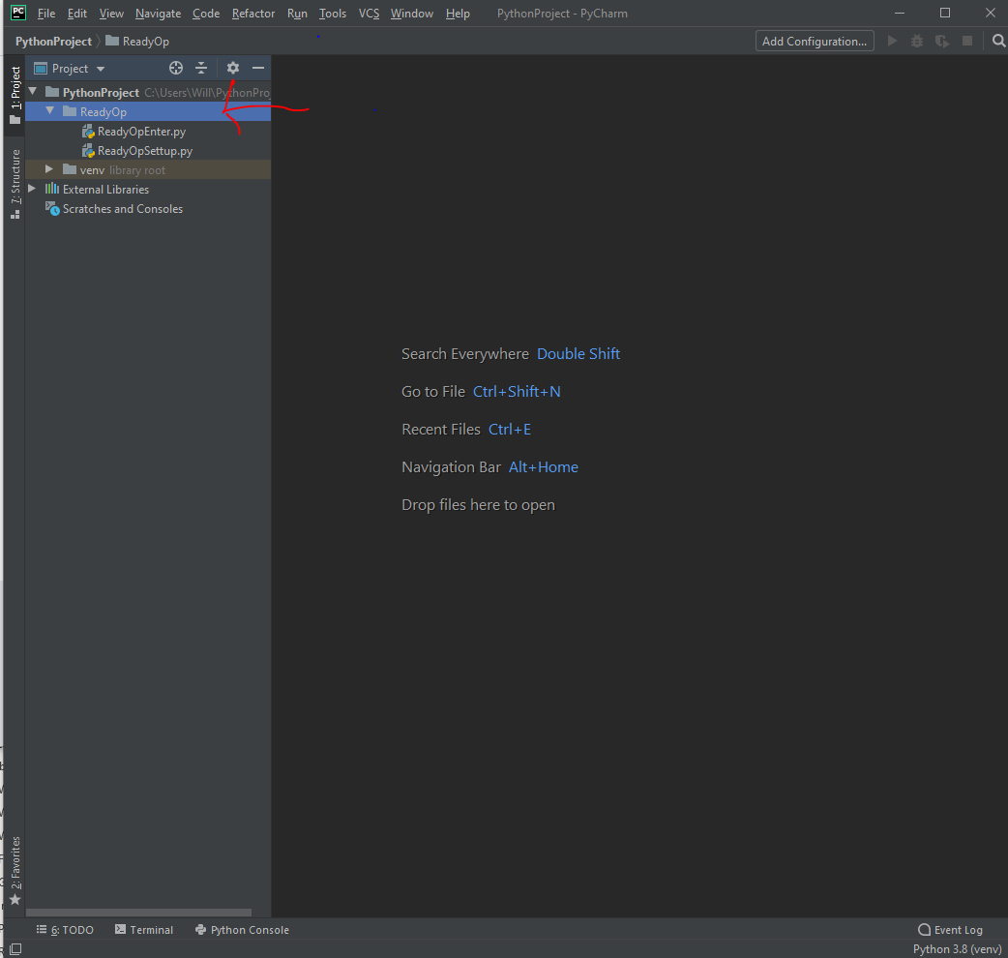

1. Open these files by double clicking on them
2. Now go to File>Settings

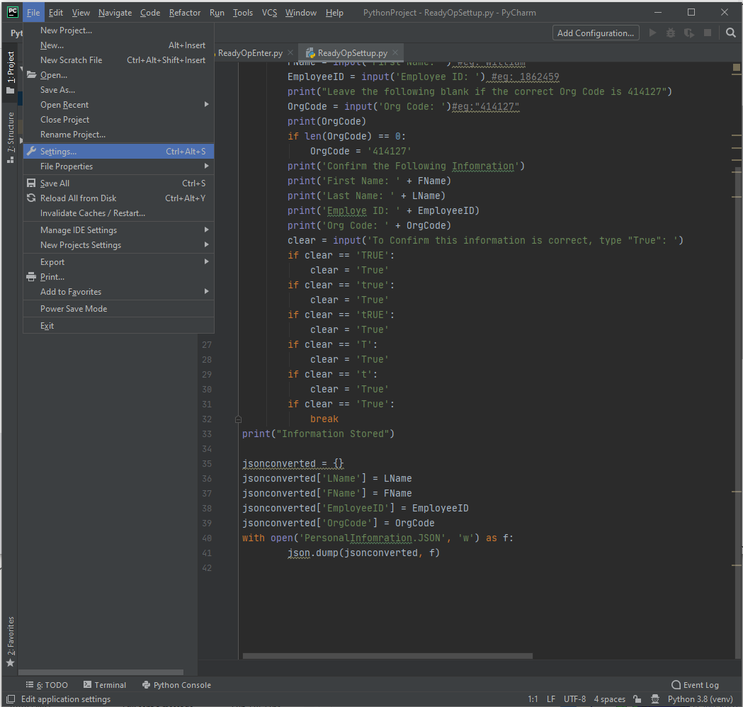

1. Go down to python Interrater in Settings:

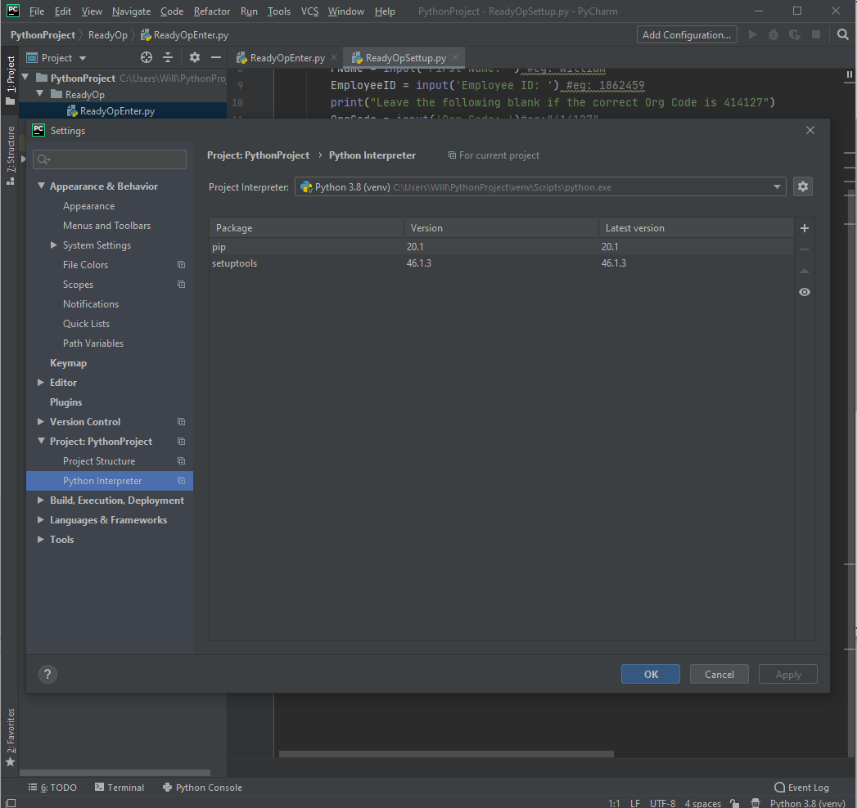

1. Click the “+” button on the right side
2. This will open a search window like this:

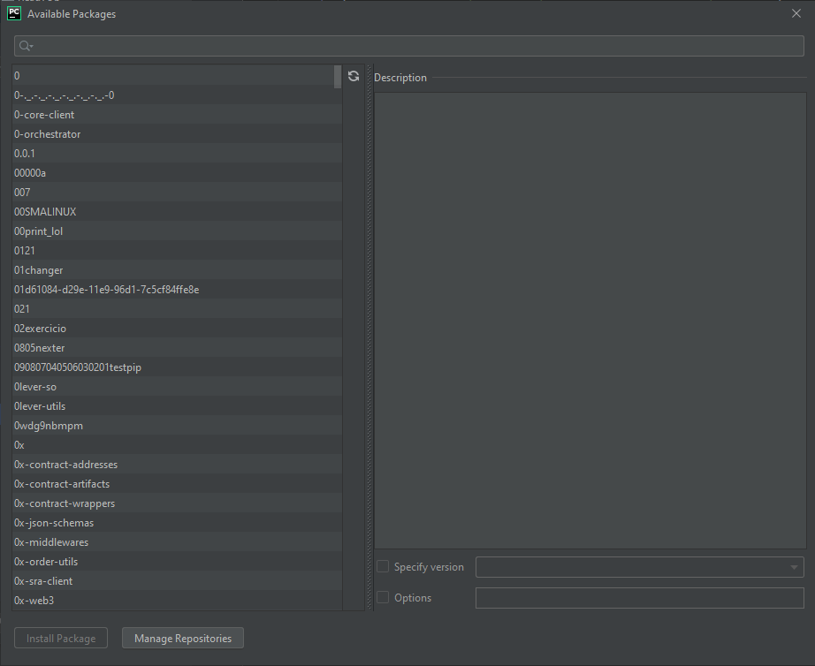

1. Type “PyAutoGui” and then click “Install Package”

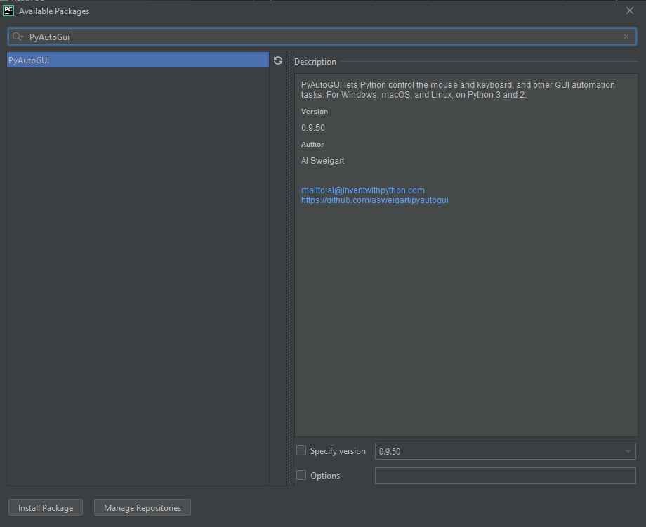

1. In a few moments, it will say “Package PyAutoGui installed successfully
2. Close the Available packages Window and the settings Window
3. Go to the ReadyOpSettup.py code

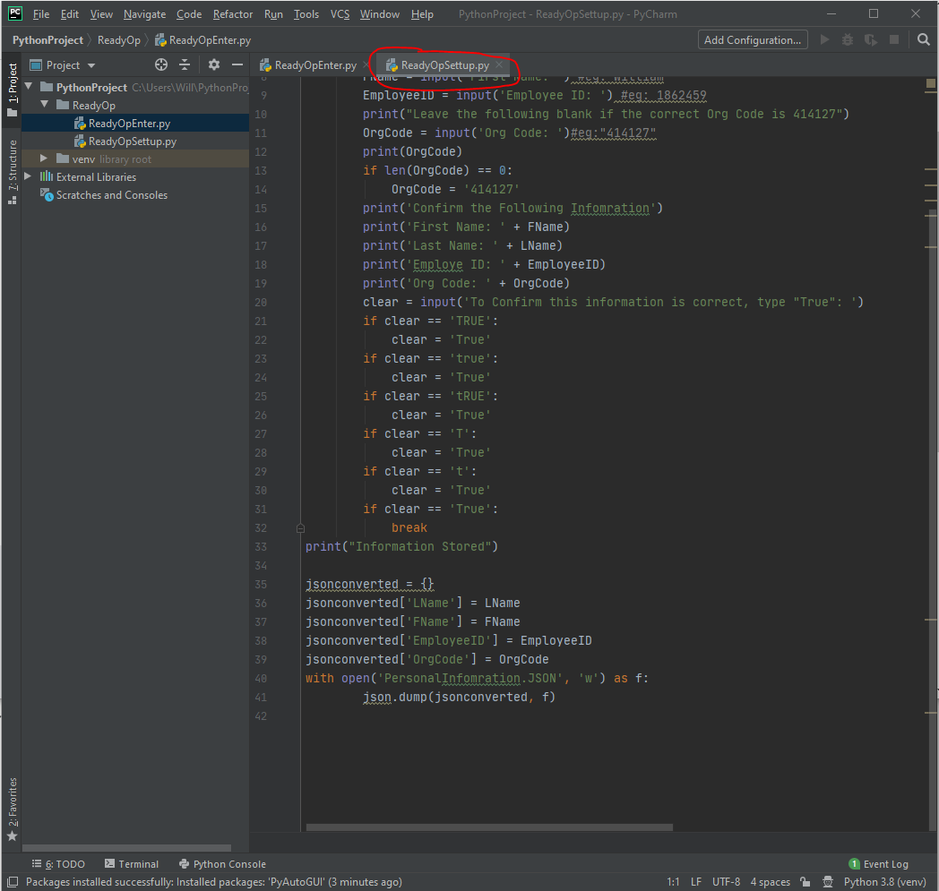

1. Right click on this and click run
2. You will now be prompted to enter some information, enter this information (in green below, then once you have entered this information, type “True”)

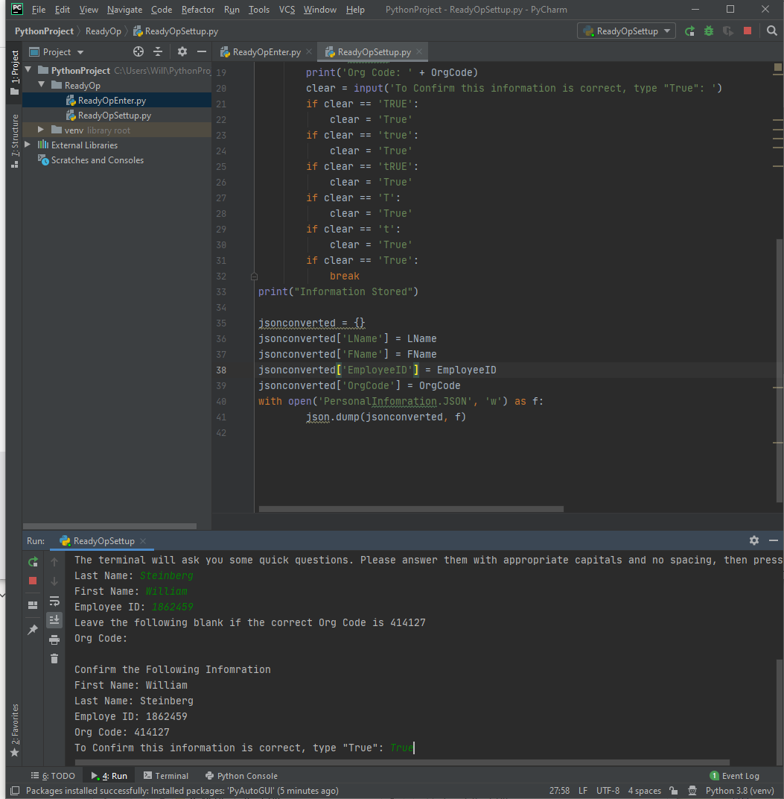

1. You will now get a message saying: “Process finished with exit code 0”
2. Now go to ReadyOpEnter.Py

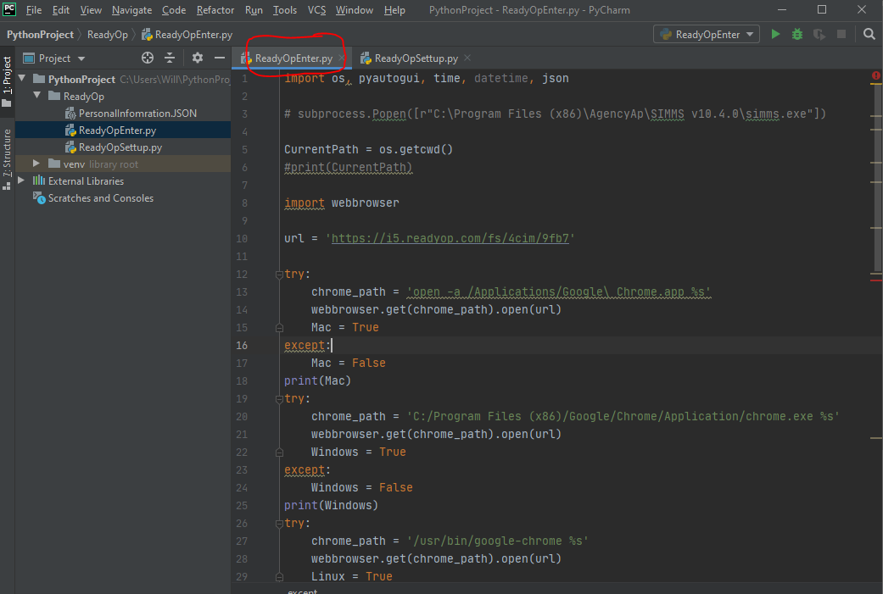

1. Right click and press run
2. This will now run the program and Auto-enter into ReadyOp.
3. IMPORTANT NOTE: If you have multiple monitors open, make sure you have Chrome up on the current monitor you are working on. To accessgitgit

To learn the python basics and learn awesome stuff go to here:

<https://automatetheboringstuff.com/>

To learn a lot of data manipulation and other cool stuff you can do go here:

<https://pandas.pydata.org/pandas-docs/stable/getting_started/index.html#getting-started>